Work report 14 sep 2021

Today I have trained the mask rcnn syncbn model till 44000 epoch with augmentation.

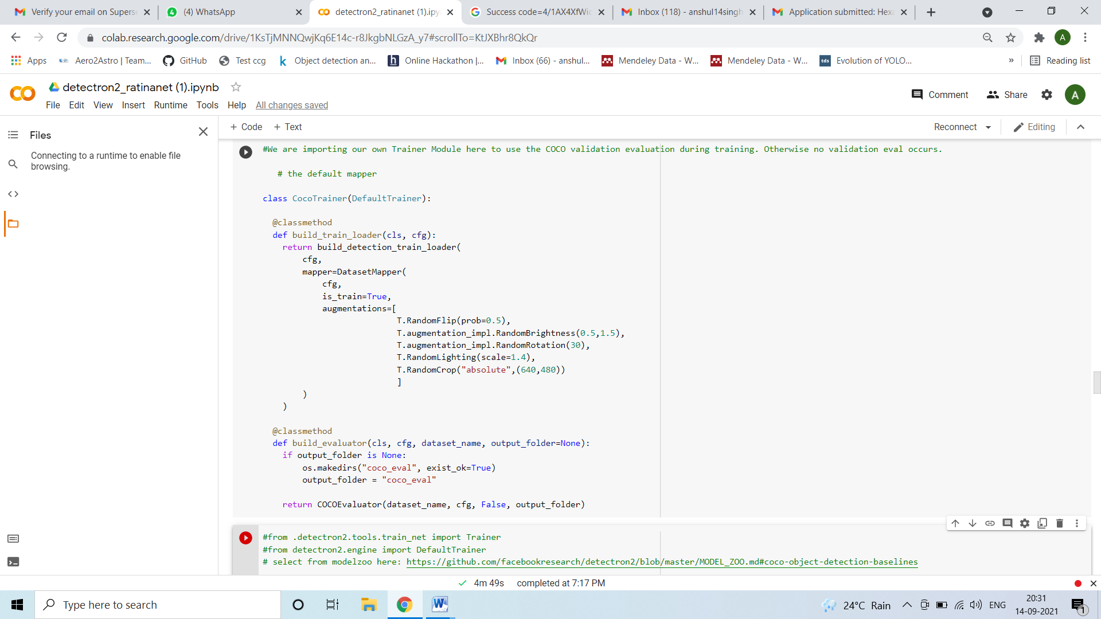

Test set:

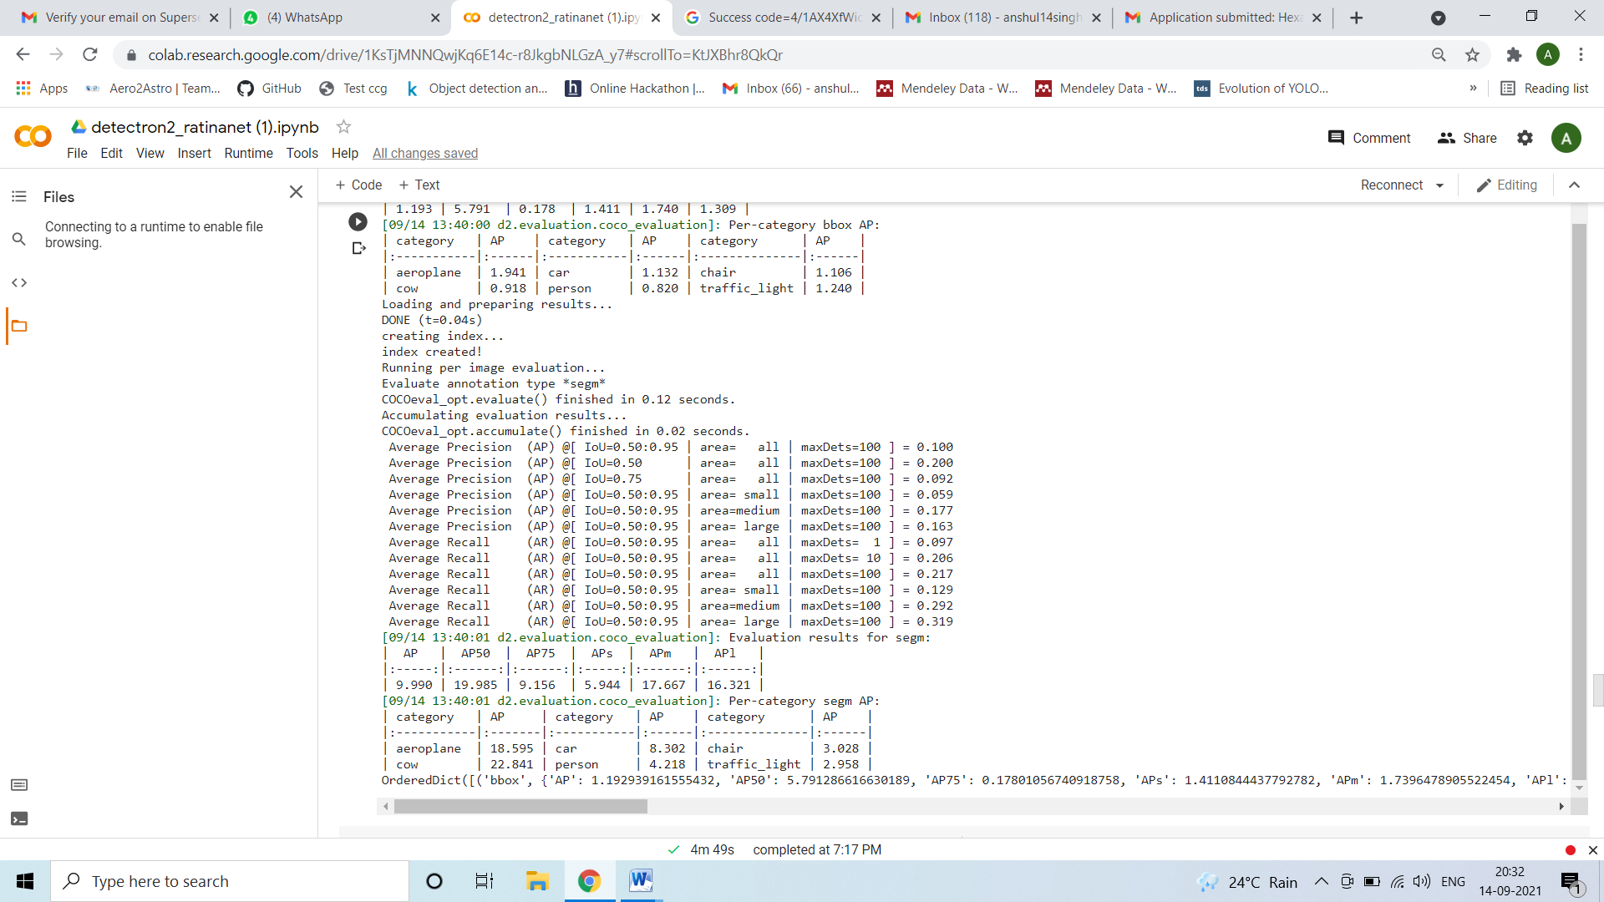

Train:

